# Data Visualization and Statistics Using Python

Name:Yousef ashraf 248527

# Visualizations

## Correlation Matrix

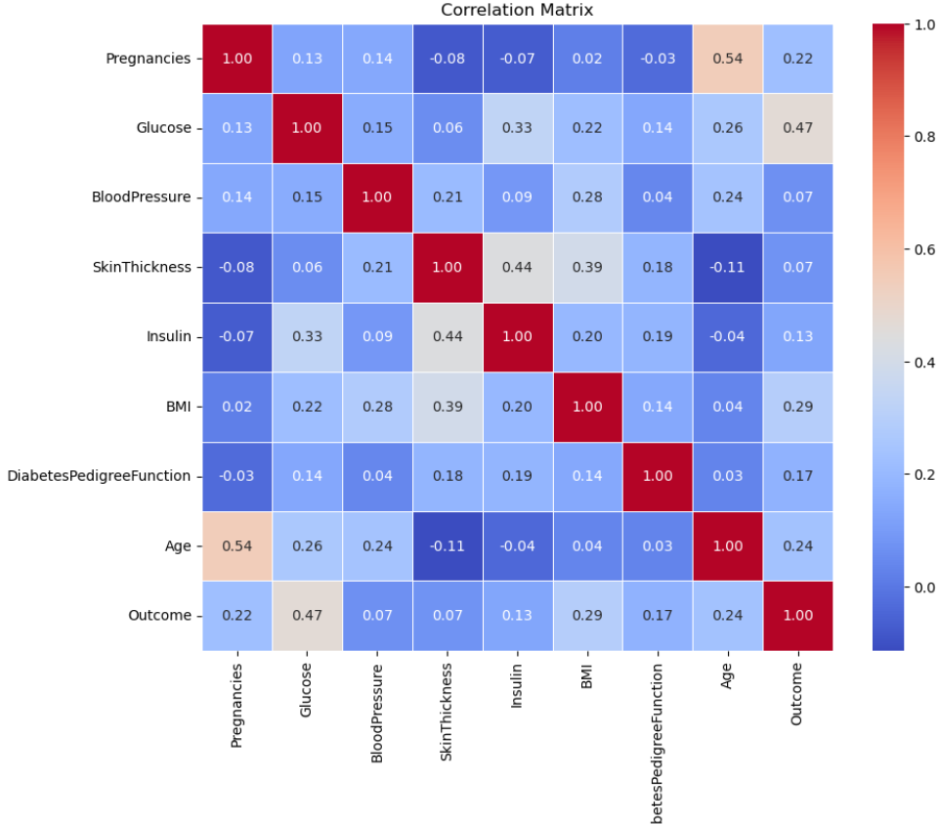

This section provides insights and analysis from the correlation matrix.

## Scatter Plot: Blood Pressure vs BMI

This section provides insights and analysis from the scatter plot: bloodpressure vs bmi.

## Distribution Plots (Pregnancies, SkinThickness, Age)

This section provides insights and analysis from the distribution plots (pregnancies, skinthickness, age).

## Pie Chart: Outcome Distribution

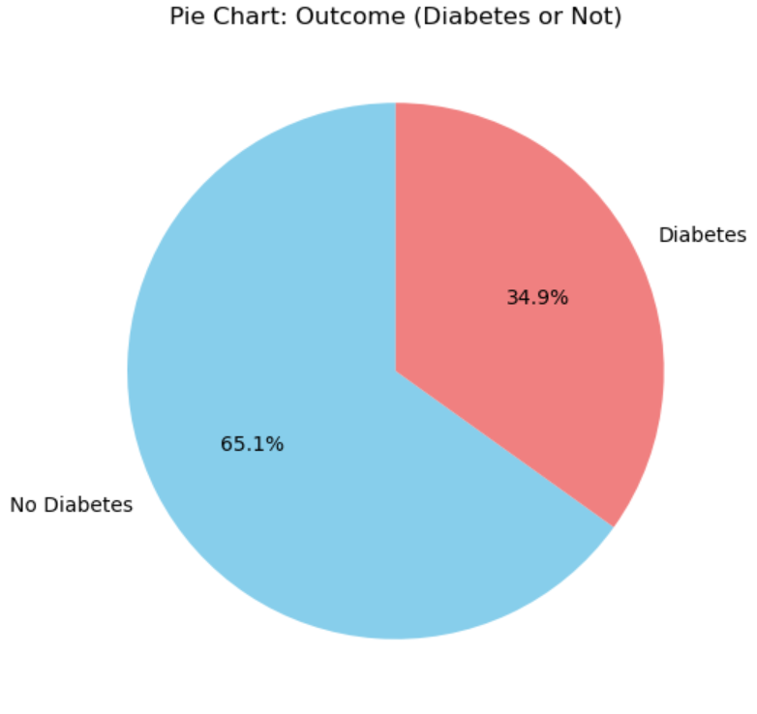

This section provides insights and analysis from the pie chart: outcome distribution.

## Box Plots (SkinThickness, DiabetesPedigreeFunction, BloodPressure)

This section provides insights and analysis from the box plots (skinthickness, diabetespedigreefunction, bloodpressure).

# Data Statistics

## Statistics for Pregnancies

Mean: 3.85

Median: 3.00

Mode: 1.00

Standard Deviation: 3.37

Variance: 11.35

Minimum: 0.00

Maximum: 17.00

## Statistics for Glucose

Mean: 120.89

Median: 117.00

Mode: 99.00

Standard Deviation: 31.97

Variance: 1022.25

Minimum: 0.00

Maximum: 199.00

## Statistics for BloodPressure

Mean: 69.11

Median: 72.00

Mode: 70.00

Standard Deviation: 19.36

Variance: 374.65

Minimum: 0.00

Maximum: 122.00

## Statistics for SkinThickness

Mean: 20.54

Median: 23.00

Mode: 0.00

Standard Deviation: 15.95

Variance: 254.47

Minimum: 0.00

Maximum: 99.00

## Statistics for Insulin

Mean: 79.80

Median: 30.50

Mode: 0.00

Standard Deviation: 115.24

Variance: 13281.18

Minimum: 0.00

Maximum: 846.00

## Statistics for BMI

Mean: 31.99

Median: 32.00

Mode: 32.00

Standard Deviation: 7.88

Variance: 62.16

Minimum: 0.00

Maximum: 67.10

## Statistics for DiabetesPedigreeFunction

Mean: 0.47

Median: 0.37

Mode: 0.25

Standard Deviation: 0.33

Variance: 0.11

Minimum: 0.08

Maximum: 2.42

## Statistics for Age

Mean: 33.24

Median: 29.00

Mode: 22.00

Standard Deviation: 11.76

Variance: 138.30

Minimum: 21.00

Maximum: 81.00

## Statistics for Outcome

Mean: 0.35

Median: 0.00

Mode: 0.00

Standard Deviation: 0.48

Variance: 0.23

Minimum: 0.00

Maximum: 1.00